BCGSV5005A - Assessment 3
Apply footing & geomechanical design principles to domestic scale bvuildings
Question 1 (Multiple Choice select the most appropriate answer)
1 | Soil samples obtained by digging test holes are used for which of the following test purposes?
 | 1. Soil classification
 | 2. Compaction
 | 3. Moisture Content
 | 4. Each of the above
2 | When performing soils investigation on possible borrow areas, you should make borings to what depth?
 | 1. 3 metre
 | 2. The depth of planned excavation
 | 3. 0.6 to1.2 metre below anticipated excavation
 | 4. Same depth as all other borings
3 | When performing soils surveys, which of the following sources should you use to obtain information pertinent to the area?
 | 1. Local contractors
 | 2. Existing mine shafts of earth cellars
 | 3. Eroded slopes
 | 4. All of the above
4 | Highly organic soil is identified by what manner?
 | 1. More than 50 percent passing a No. 200 sieve
 | 2. 50 percent or more retained on a No. 200 sieve
 | 3. Determining that the sample is neither a fine-grained nor coarse-grained soil
 | 4. Visual inspection
5 | To classify a coarse-grained soil, you would use what sieve?
 | 1. 1/4 inch
 | 2. No. 4
 | 3. No. 40
 | 4. No. 200
6 | Coarse-grained soils with more than 12-percent fines are classified by what characteristic(s)?
 | 1. Cohesiveness
 | 2. Liquid limit
 | 3. Plasticity index
 | 4. Both 2 and 3 above
7 | For a soil sample to be classified as silty gravel, the plasticity index should be
 | 1. more than 7
 | 2. between 4 and 7
 | 3. less than 4
 | 4. unmeasurable
8 | Fine-grained soils are classified based on what requirement?
 | 1. Plasticity index
 | 2. Grain-size distribution
 | 3. Percentage of organic material
 | 4. Liquid limit
9 | Plastic silts have what group designation?
 | 1. MH
 | 2. ML
 | 3. MP
 | 4. MW
10 | What is the most useful tool for performing field identification tests?
 | 1.A hand auger
 | 2. A scale or balance
 | 3. A No. 40 sieve
 | 4. A No. 200 sieve
11 | Visual examination is used to establish which of the following properties of the soil?
 | 1. Color
 | 2. Grain distribution
 | 3. Cohesiveness of the soil
 | 4. Grain shape of the fines
12 | When the color of a soil has been identified through a visual examination, what other data should you note regarding the soil condition at the time of identification?
 | 1. Temperature
 | 2. Maximum particle size
 | 3. Chemical content
 | 4. Moisture content
13 | You have determined the soil to be coarse-grained and estimated the fines to be 4 percent. What is the soil classification of the soil?
 | 1. GW-GM
 | 2. SW-SM
 | 3. GC
 | 4. Gravel or sand, depending on additional information
14 | To determine the texture of the soil, it is recommended you rub the soil
 | 1. on the back of your hand and allow the sample to dry
 | 2. on a tender skin area, such as the wrist
 | 3. between dry fingers
 | 4. between slightly oiled fingers
15 | Which of the following requirements is true of a test pit excavation?
 | 1. Must be large enough for a man to enter
 | 2. Must be made with power-driven equipment
 | 3. Must be below the water table
4. Load-bearing tests must be performed on soil samples taken every
450 mm
 | 8 MC-questions must be correctly answered to receive a CO
 | Sieves Series Numbers are shown on the sieve chart (Question 4)
P H
Question 2
Name two (2) characteristic properties that the following soils can exhibit:
- Granular or non-cohesive soils

- Cohesive soils

P H

Question 3
A sample of soil has been vigorously shaken in a jar and after some time all soil particles have settled at the bottom of the jar forming three destinct layers. The lower layer measured 44 mm, the middle layer measured 34 mm and the top layer measured15 mm. On the chart below point out the classification of the soil and name its type.
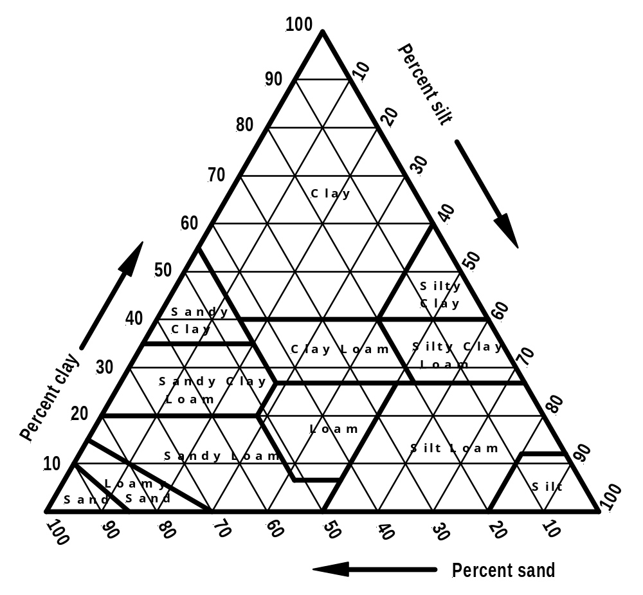
P H
Question 4

- The results of a sieve analysis is shown in the opposite table
Sieve analysis
Sieve size | Mass  reained | Mass  passing | Percentage
19 | 0 | 231
9.5 | 56
4.75 | 39
1.18 | 26
0.425 | 32
0.15 | 22
0.075 | 26
Pan | 30 | 0
 | 231
Complete the mass passing figures and the percentages figures in the table

- Plot the percentages figures in the chart below.

- How would you classify this soil sample?

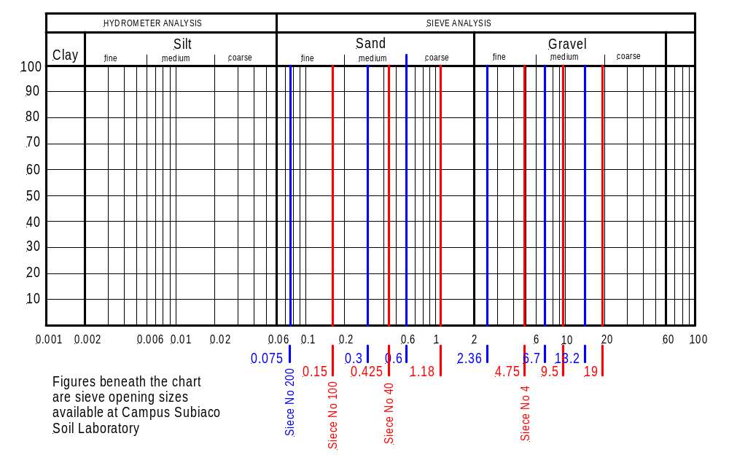
4.3 - Classification:

P H

End of assessment

